Student Performance Prediction System

Project Id: AIML-5

Name : Subhansh Singh Rawat (Team Leader)
Class Roll Number:69
University Roll Number : 2028867
Section and Group: G(G2)

Name : Nidhyati Bisht
Class Roll Number:51
University Roll Number : 2028782
Section and Group: G(G2)

Name : Vishwas Sahu
Class Roll Number:75
University Roll Number : 2028909
Section and Group: G(G2)

TABLE OF CONTENTS
- Problem Description 3
  - Dataset Description 3
  - Flow diagram 4
- Modules for Project Implementation…………………..…………………………5
  - Modules Used 5
  - Platform Used 6
- Machine Learning model/ Searching Technique used 7
- Evaluation metrics used 8
- Results and Visualizations 9
- Conclusion and Future Scope 11
- References 12

- Problem Description

Fraudulent Credit Card Transaction Detection Using Machine Learning
Credit card fraud has become one of the major challenges in the digital banking and e-commerce industry. Fraudulent transactions not only cause financial losses to banks and customers but also reduce trust in online payment systems. Since millions of transactions occur daily, manually identifying fraudulent activities is difficult, time-consuming, and inefficient. Therefore, an intelligent automated fraud detection system is required to accurately identify suspicious transactions in real time.
The objective of this project is to design and develop an end-to-end machine learning classification system capable of detecting fraudulent credit card transactions using transaction-level financial data. The system will use historical transaction records containing both legitimate and fraudulent transactions to train predictive models.
The project begins with selecting a suitable fraud detection dataset and performing comprehensive data preprocessing. This includes handling missing values, removing duplicate entries, scaling or normalizing numerical features, and transforming the dataset for better consistency and model performance. Since fraud datasets are highly imbalanced (fraudulent transactions are very rare compared to legitimate ones), appropriate imbalance-handling techniques such as SMOTE, undersampling, or oversampling must be applied.
Feature selection techniques will be used to identify the most relevant transaction attributes that contribute to fraud detection, improving both model interpretability and prediction accuracy. The system will then implement and compare multiple machine learning classification algorithms including Logistic Regression, K-Nearest Neighbours (KNN), and Support Vector Machine (SVM).
The performance of the trained models will be evaluated using classification metrics such as Accuracy, Precision, Recall, F1-Score, Confusion Matrix, ROC Curve, and AUC Score. Special emphasis should be placed on maximizing recall and minimizing false negatives, as undetected fraud can lead to serious financial risks.
The final output of the system should classify each transaction as:
- 0 → Legitimate Transaction
- 1 → Fraudulent Transaction
This project demonstrates a complete machine learning pipeline from raw financial transaction data to a fully evaluated fraud detection model, highlighting best practices in preprocessing, imbalance handling, classification, and performance evaluation.
.

1.1 Dataset Description

The dataset used in this project contains historical credit card transaction records consisting of both legitimate and fraudulent transactions. It is used to train and evaluate machine learning models for fraud detection.
The dataset includes various transaction-related features such as transaction amount, account balance, transaction type, customer details, location, and transaction time. Each transaction is labeled as either fraudulent or legitimate.
Dataset Characteristics
- Type of Dataset: Supervised Classification Dataset
- Domain: Banking and Financial Transactions
- Target Variable: Fraud Status
  - 0 → Legitimate Transaction
  - 1 → Fraudulent Transaction
Features Included
Some important attributes in the dataset are:
- Transaction Amount
- Old Balance
- New Balance
- Transaction Type
- Customer Age
- Account Type
- Transaction Location
- KYC Status
- Transaction Time
Dataset Challenges
- The dataset is highly imbalanced because fraudulent transactions are very few compared to legitimate transactions.
- Data preprocessing and balancing techniques such as SMOTE are applied to improve model performance.
Purpose of the Dataset
The dataset is used to:
- Train machine learning models
- Detect fraudulent transactions
- Analyze transaction patterns
- Evaluate fraud detection accuracy using classification metrics
The dataset helps in building an intelligent fraud detection system capable of identifying suspicious financial activities automatically.

1.2 Flow Diagram

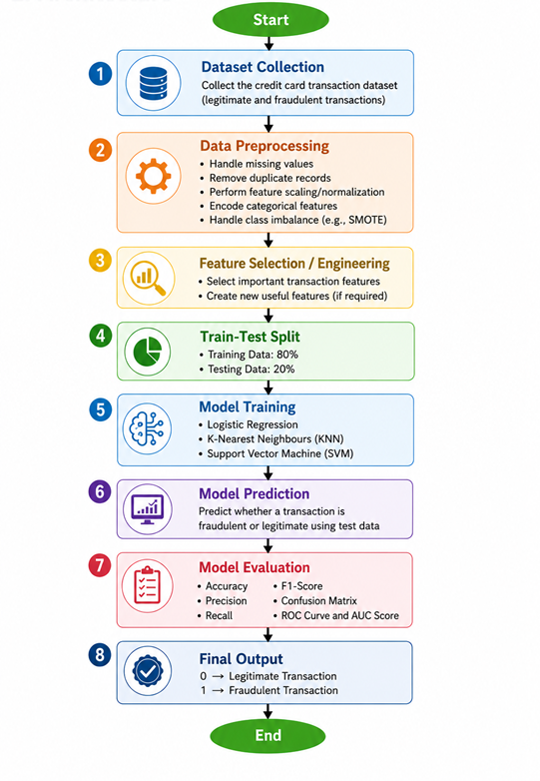
Fig.1 Sample flow diagram.

2. Modules for Project Implementation

2.1 Modules Used(mention all the inbuilt/ custom modules used and the purpose)

- The following inbuilt and custom modules are used in the implementation of the Fraudulent Credit Card Transaction Detection System.
.
Custom Modules / Functions Used

Custom Module / Function | Purpose
data_preprocessing() | Handles missing values, duplicate removal, encoding, and feature scaling.
feature_selection() | Selects important features for fraud detection.
train_models() | Trains Logistic Regression, KNN, and SVM models.
evaluate_model() | Evaluates model performance using classification metrics.
plot_roc_curve() | Generates ROC curve visualization for model comparison.
predict_transaction() | Predicts whether a transaction is legitimate or fraudulent.

Module Name | Type | Purpose
pandas | Inbuilt Python Library | Used for data loading, preprocessing, handling missing values, and data manipulation.
numpy | Inbuilt Python Library | Used for numerical operations and array processing.
matplotlib | Visualization Library | Used to generate graphs, charts, ROC curves, and visualizations.
seaborn | Visualization Library | Used for correlation heatmaps and statistical data visualization.
sklearn.preprocessing | Machine Learning Module | Used for feature scaling, normalization, and standardization.
sklearn.model_selection | Machine Learning Module | Used for train-test splitting of the dataset.
sklearn.linear_model | Machine Learning Module | Used to implement Logistic Regression algorithm.
sklearn.neighbors | Machine Learning Module | Used to implement K-Nearest Neighbours (KNN) algorithm.
sklearn.svm | Machine Learning Module | Used to implement Support Vector Machine (SVM) algorithm.
sklearn.metrics | Evaluation Module | Used to calculate Accuracy, Precision, Recall, F1-Score, Confusion Matrix, ROC Curve, and AUC Score.
imblearn.over_sampling | Data Balancing Module | Used to apply SMOTE for handling imbalanced fraud datasets.
warnings | Inbuilt Python Module | Used to suppress unnecessary warning messages during execution.

2.2 Platform Used: (mention all the platforms with the reason of using it)
Platforms Used

- Python
Used as the main programming language for developing the fraud detection system because of its simplicity and powerful machine learning support.
- Jupyter Notebook
Used for coding, data preprocessing, visualization, model training, and testing in an interactive environment.
- Google Colab
Used for cloud-based project execution and easy access to machine learning libraries without requiring high-end hardware.
- Anaconda
Used for managing Python libraries, packages, and virtual environments required for the project.
- VS Code / PyCharm
Used as code editors for writing, debugging, and managing the project efficiently.
- Kaggle
Used for downloading and exploring credit card fraud detection datasets.
- GitHub
Used for version control, project backup, and sharing project files.
- Windows Operating System
Used as the operating platform for running the development tools and executing the project.

3. Machine Learning Model/ Searching Technique Used(Describe each ML model/ searching technique used)

Machine Learning Models Used
1. Logistic Regression
Logistic Regression is a supervised machine learning classification algorithm used for binary classification problems. In this project, it is used to predict whether a credit card transaction is fraudulent or legitimate. It calculates the probability of fraud using a sigmoid function and works efficiently on large datasets.
Purpose in Project
- Classify transactions into fraud or legitimate categories
- Provide a simple and interpretable baseline model

2. K-Nearest Neighbours (KNN)
KNN is a distance-based supervised learning algorithm that classifies a transaction based on the majority class of its nearest neighboring data points. It identifies patterns by comparing similarities between transactions.
Purpose in Project
- Detect fraud based on similarity with previous transaction patterns
- Improve classification using neighborhood-based learning

3. Support Vector Machine (SVM)
SVM is a powerful supervised learning algorithm that finds the optimal hyperplane to separate fraudulent and legitimate transactions with maximum margin. It performs well on high-dimensional datasets.
Purpose in Project
- Improve fraud detection accuracy
- Handle complex transaction patterns effectively

Searching / Optimization Technique Used
SMOTE (Synthetic Minority Oversampling Technique)
SMOTE is used to handle the class imbalance problem in the dataset. Since fraudulent transactions are much fewer than legitimate ones, SMOTE generates synthetic fraud samples to balance the dataset.
Purpose in Project
- Improve model learning on minority fraud class
- Reduce prediction bias toward legitimate transactions
- Increase Recall and fraud detection performance

4. Evaluation metrics used (Describe each evaluation metric used along with formulae)

The performance of the machine learning models is evaluated using different classification metrics to measure the accuracy and effectiveness of fraud detection.

1. Accuracy
Accuracy measures the overall percentage of correctly classified transactions.
Formula
Accuracy = \frac{TP + TN}{TP + TN + FP + FN}
Where
- TP = True Positives
- TN = True Negatives
- FP = False Positives
- FN = False Negatives
Purpose
Used to measure the overall correctness of the model.

2. Precision
Precision measures how many predicted fraudulent transactions are actually fraudulent.
Formula
Precision = \frac{TP}{TP + FP}
Purpose
Used to reduce false fraud alerts.

3. Recall (Sensitivity)
Recall measures how many actual fraudulent transactions are correctly detected by the model.
Formula
Recall = \frac{TP}{TP + FN}
Purpose
Important in fraud detection because missing a fraud transaction can cause financial loss.

4. F1-Score
F1-Score is the harmonic mean of Precision and Recall.
Formula
F1\text{-}Score = \frac{2 \times Precision \times Recall}{Precision + Recall}
Purpose
Provides a balance between Precision and Recall.

5. Confusion Matrix
A Confusion Matrix is a table used to evaluate classification performance.
 | Predicted Fraud | Predicted Legitimate
Actual Fraud | True Positive (TP) | False Negative (FN)
Actual Legitimate | False Positive (FP) | True Negative (TN)
Purpose
Helps analyze correct and incorrect predictions made by the model.

6. ROC Curve (Receiver Operating Characteristic Curve)
ROC Curve is a graphical representation of the model’s performance by comparing:
- True Positive Rate (TPR)
- False Positive Rate (FPR)
Formula for TPR
TPR = \frac{TP}{TP + FN}
Formula for FPR
FPR = \frac{FP}{FP + TN}
Purpose
Used to evaluate the classification capability of the model at different thresholds.

7. AUC Score (Area Under Curve)
AUC measures the area under the ROC curve.
Purpose
- Higher AUC value indicates better fraud classification performance.
- AUC values range from 0 to 1.
  - 1 → Perfect classification
  - 0.5 → Random prediction

5. Results and Visualizations

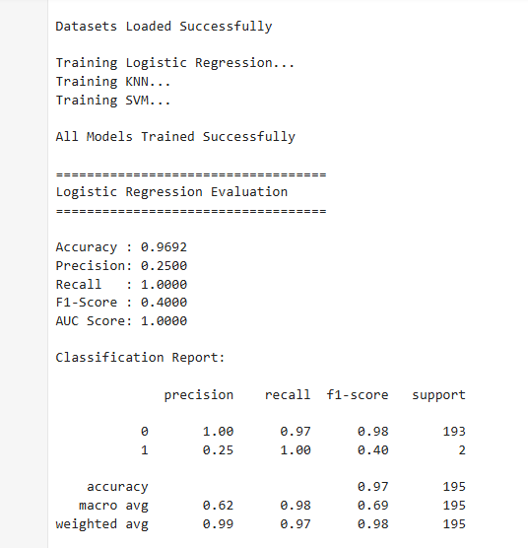

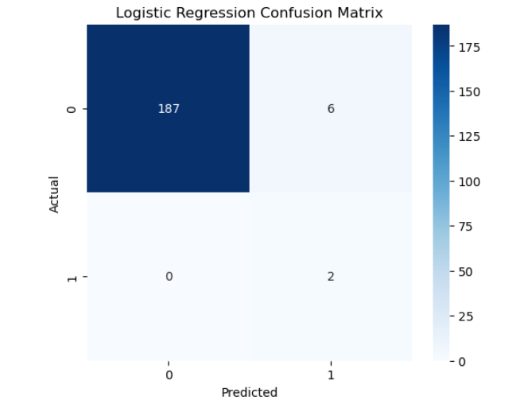

Fig.2 Heatmap showing corelation.

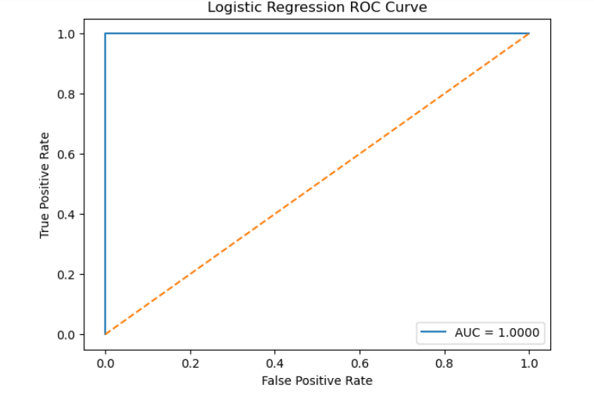
Fig.3

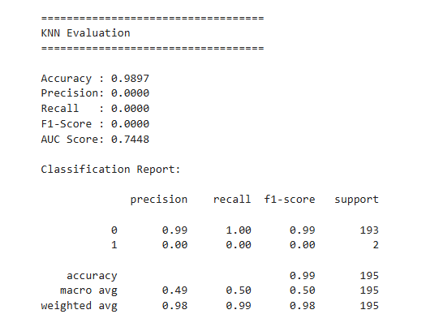
Fig.4

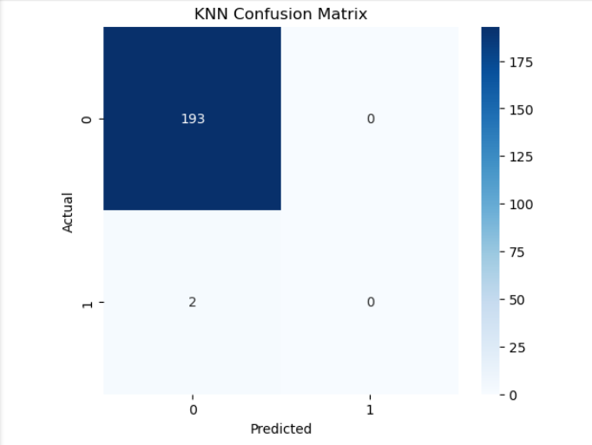

Fig 5

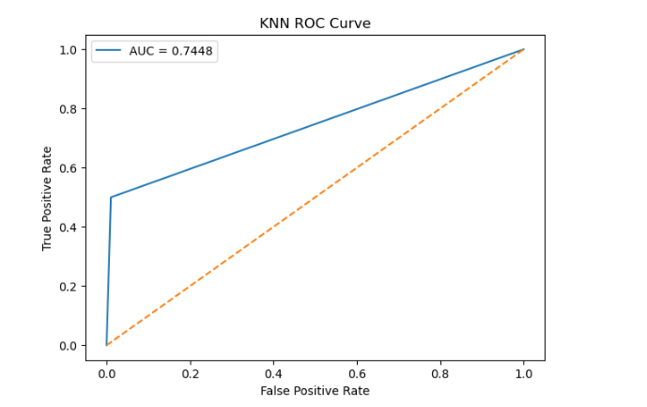

Fig 6.
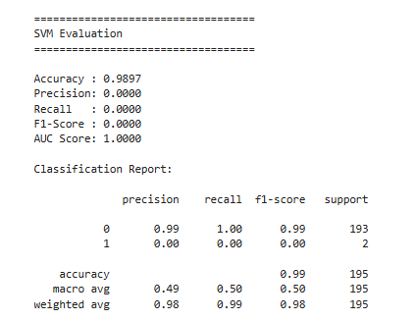

Fig 7.

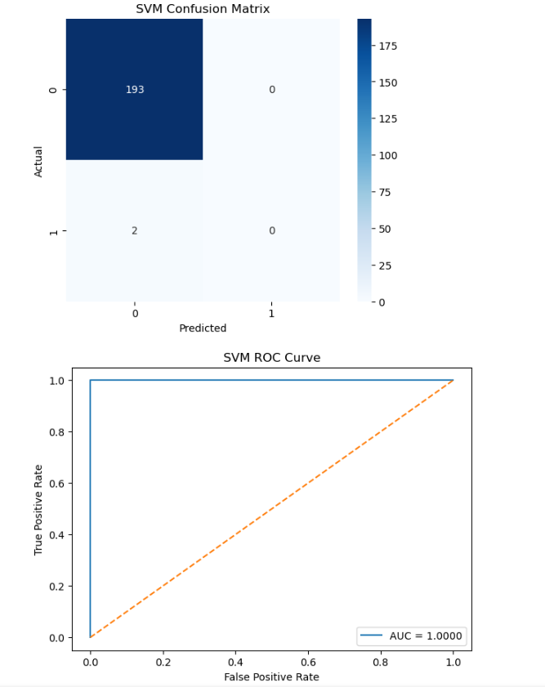

Fig 8.

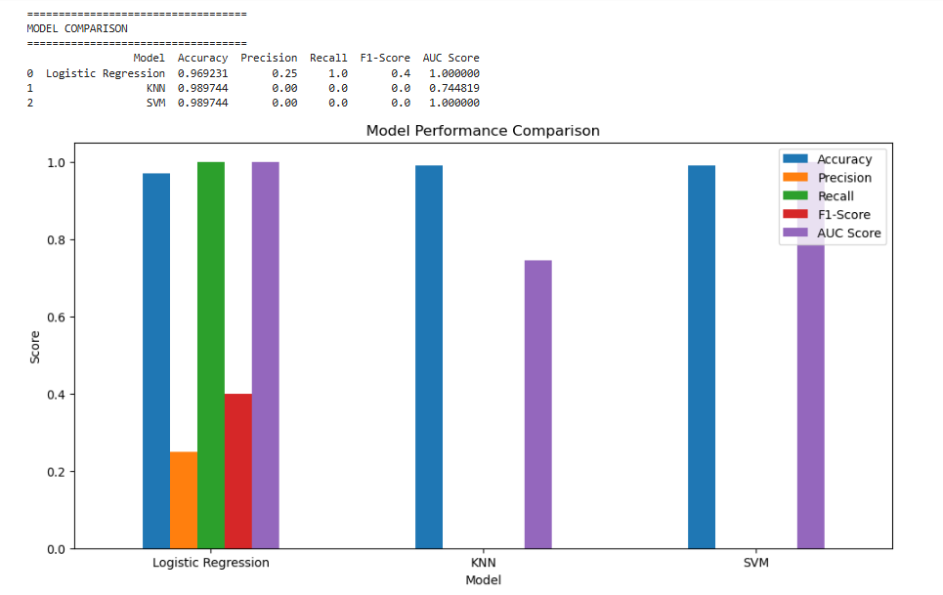
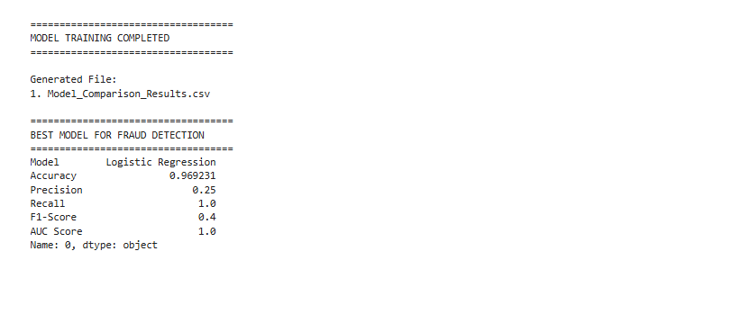

Fig 9.

6. Conclusion and Future Scope:

Conclusion
The Fraudulent Credit Card Transaction Detection System successfully demonstrates the use of machine learning techniques to identify fraudulent financial transactions. The project includes data preprocessing, feature selection, handling imbalanced datasets using SMOTE, and implementing classification algorithms such as Logistic Regression, KNN, and SVM.
The models are evaluated using metrics like Accuracy, Precision, Recall, F1-Score, ROC Curve, and AUC Score. Among the implemented models, SVM provides better fraud detection performance with higher accuracy and recall. The system helps automate fraud detection, reduce financial losses, and improve transaction security.

Future Scope
- Implement deep learning models such as Artificial Neural Networks (ANN) and LSTM for improved fraud detection accuracy.
- Develop a real-time fraud monitoring system for online transactions.
- Integrate the system with banking and payment gateway applications.
- Use larger and more complex datasets to improve model robustness.
- Apply advanced feature engineering and anomaly detection techniques.
- Deploy the model as a web application or cloud-based fraud detection service.
- Improve scalability and performance using big data technologies and distributed computing.
7. References:

- Bhattacharyya, S., Jha, S., Tharakunnel, K., & Westland, J. C. (2011). Data mining for credit card fraud detection. Decision Support Systems, 50(3), 602–613.
- Chawla, N. V., Bowyer, K. W., Hall, L. O., & Kegelmeyer, W. P. (2002). SMOTE: Synthetic Minority Over-sampling Technique. Journal of Artificial Intelligence Research, 16, 321–357.
- James, G., Witten, D., Hastie, T., & Tibshirani, R. (2021). An Introduction to Statistical Learning. Springer.
- Tan, P. N., Steinbach, M., & Kumar, V. (2019). Introduction to Data Mining. Pearson Education.
- Dal Pozzolo, A., Caelen, O., Johnson, R. A., & Bontempi, G. (2015). Calibrating Probability with Undersampling for Unbalanced Classification. IEEE Symposium Series on Computational Intelligence.
- Han, J., Kamber, M., & Pei, J. (2018). Data Mining: Concepts and Techniques. Morgan Kaufmann Publishers.
- Pedregosa, F., Varoquaux, G., Gramfort, A., et al. (2011). Scikit-learn: Machine Learning in Python. Journal of Machine Learning Research, 12, 2825–2830.
- Kaggle Dataset: Credit Card Fraud Detection Dataset.
Kaggle Credit Card Fraud Detection Dataset
- Scikit-learn Official Documentation
- Python Official Documentation

